**Fast Guide on How to Use the Application:**

I have published the container/image in hub.docker.com. You can now use it anywhere (as long as you have docker setup).

**Lock**

1. To run lock, execute in the commandline "docker pull aliahmedahmed/python-lock".
2. Then do "docker run -i -t aliahmedahmed/python-lock".

**Hub**

1. To run the hub.py - go to the commandline, execute "docker pull aliahmedahmed/python-hub" to

pull

1. Then to execute "docker run -i -t aliahmedahmed/python-hub"

**See below screenshot of lock.py and hub.py running.**

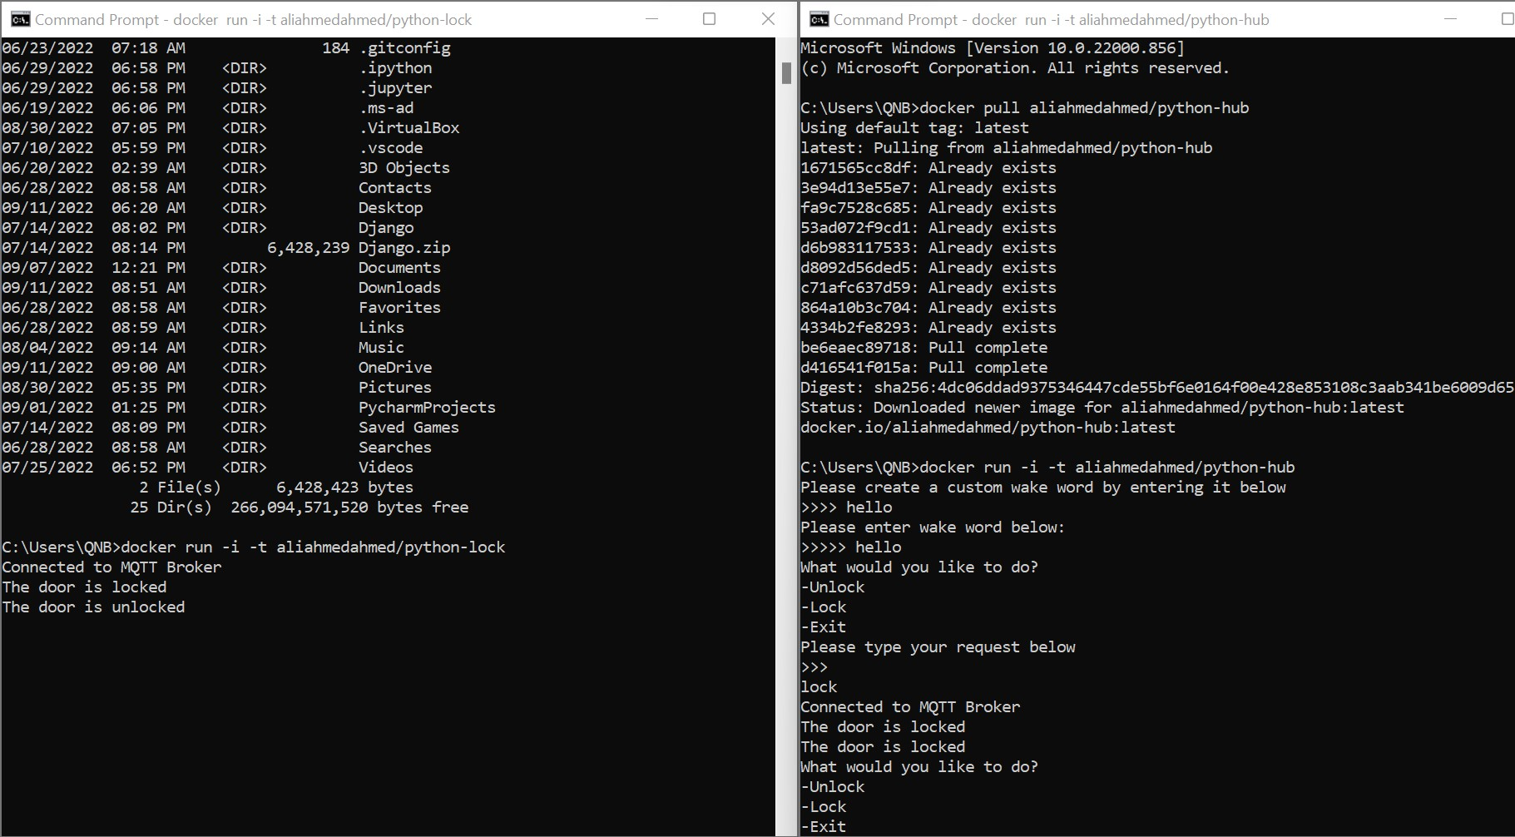

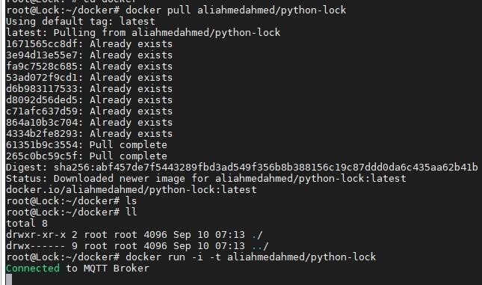

**Connected to MQTT Broker that’s prove that it's exists and create successfully**

# MQTT Server Setup (mqtt.aliahmed.app)

**See below mosquitto server status:**

**systemctl status mosquito :**

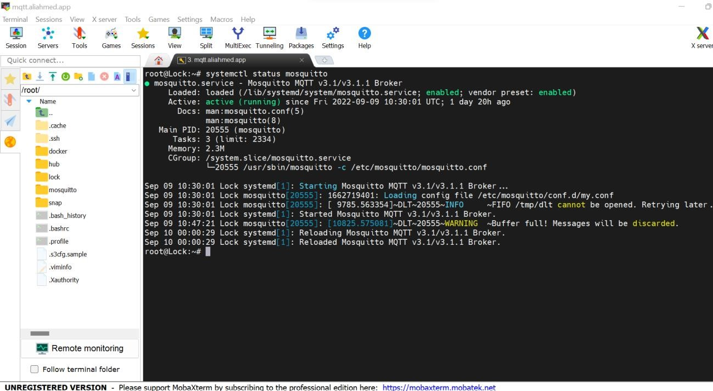

# Application Code Development

We have developed the program together with the team. My focus was to ensure the data entry/input is constantly looping, and ensuring the lock/hub client connects properly using a unique client ID.

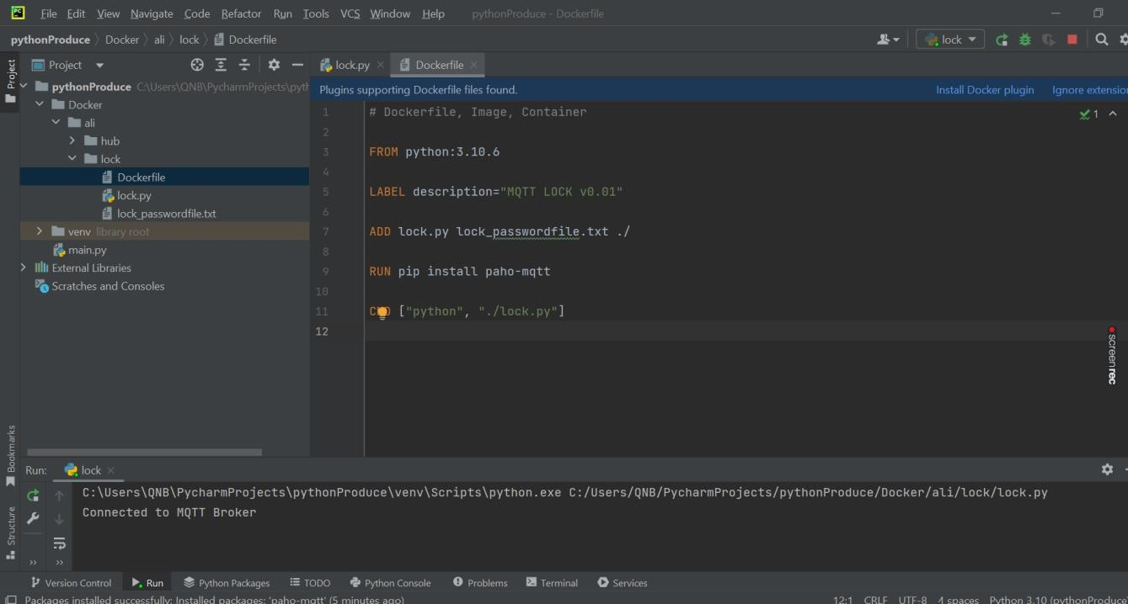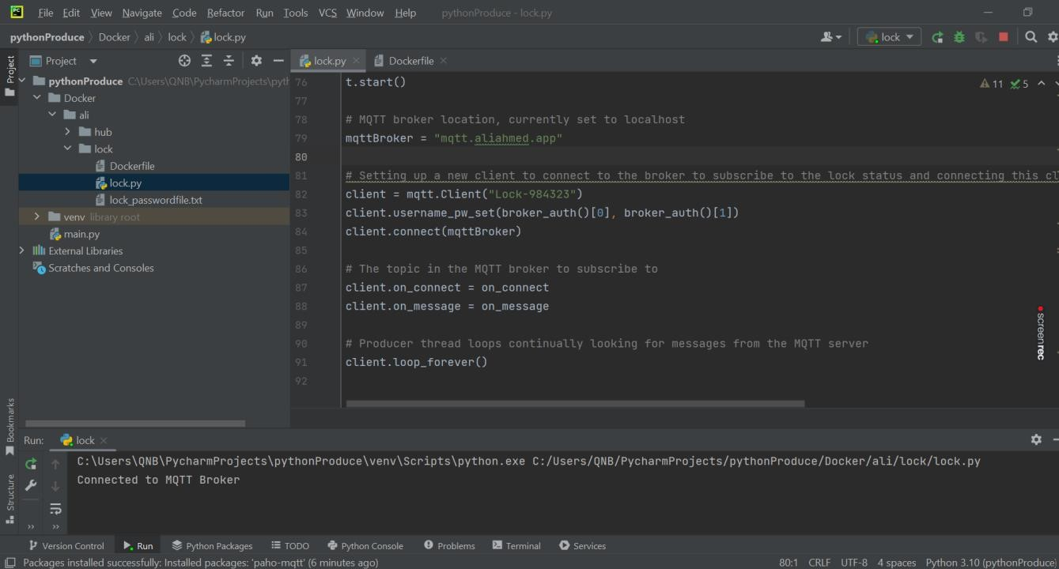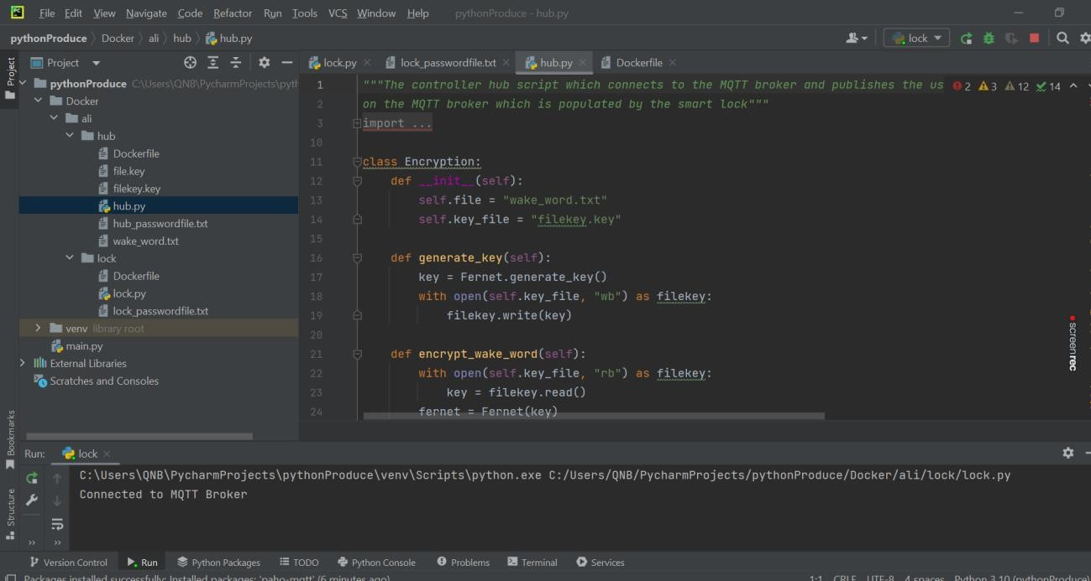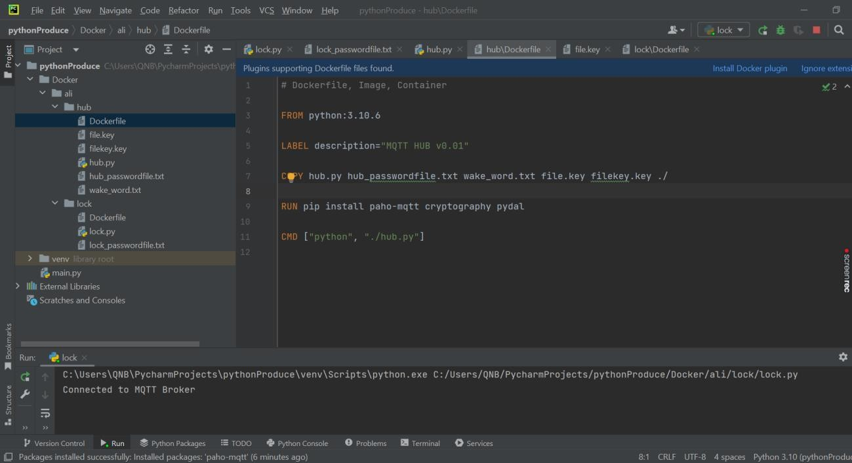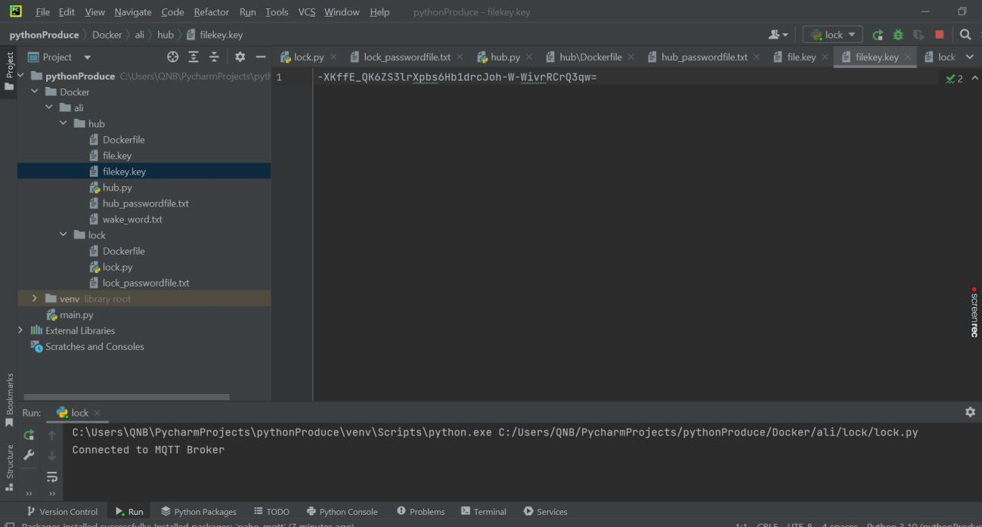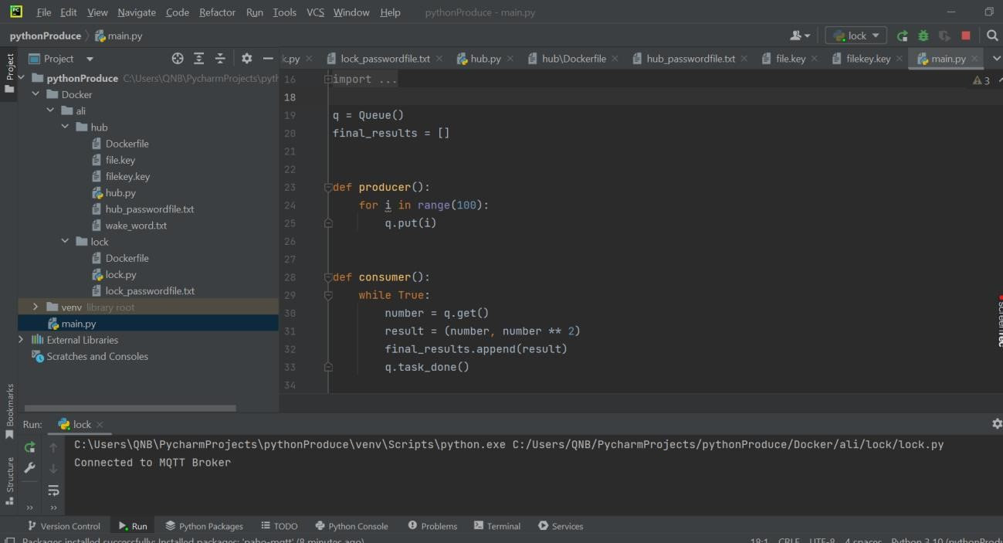

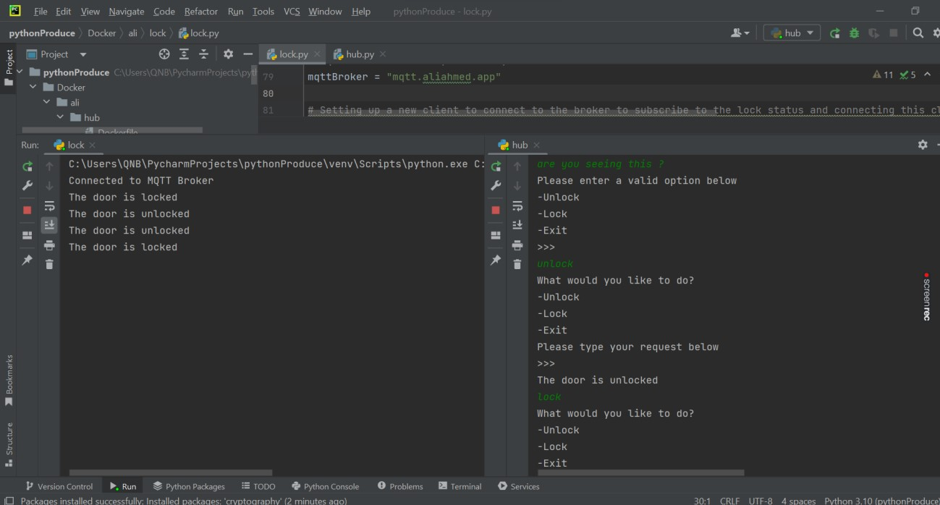

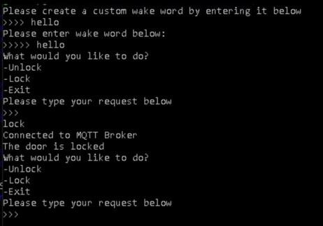

# Application Deployment Using Docker

Created a docker hub under my name and published both hub.py and lock.py application on it.

[**https://hub.docker.com/r/aliahmedahmed/**](https://hub.docker.com/r/aliahmedahmed/)

Using Visual Studio Code I created the Docker file and build the hub.py and lock.py, see below build commands: docker build -t aliahmedahmed/python-hub . docker build -t aliahmedahmed/python-lock .

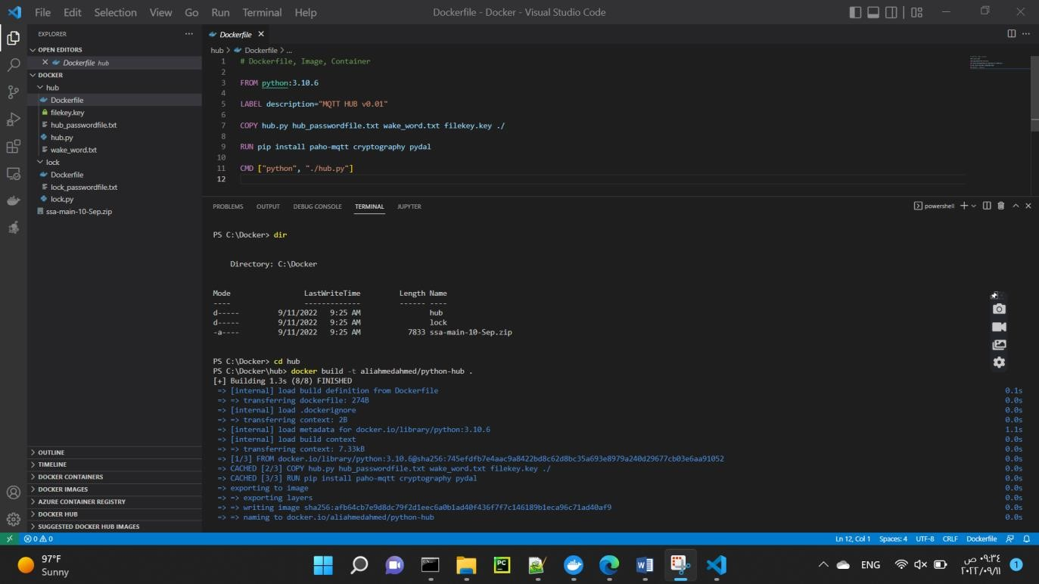

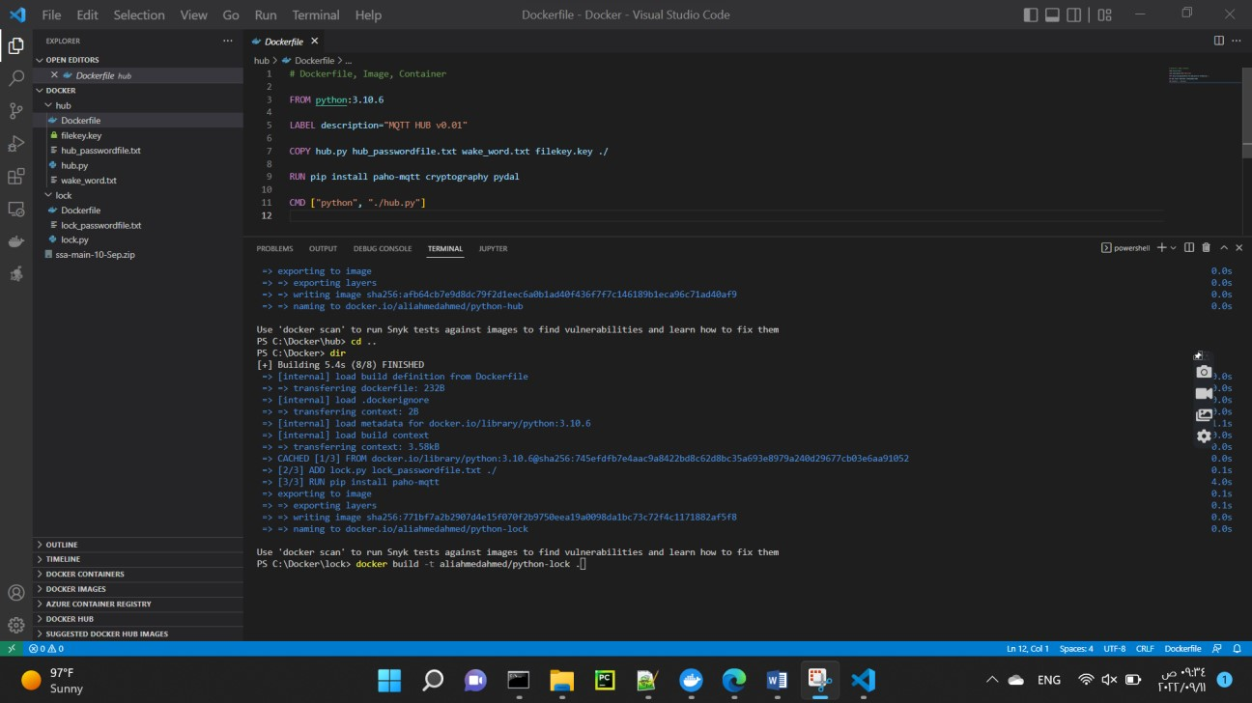

**Upon completion of the build, I push the images to docker using the below commands:**

docker push aliahmedahmed/python-lock

docker push aliahmedahmed/python-hub

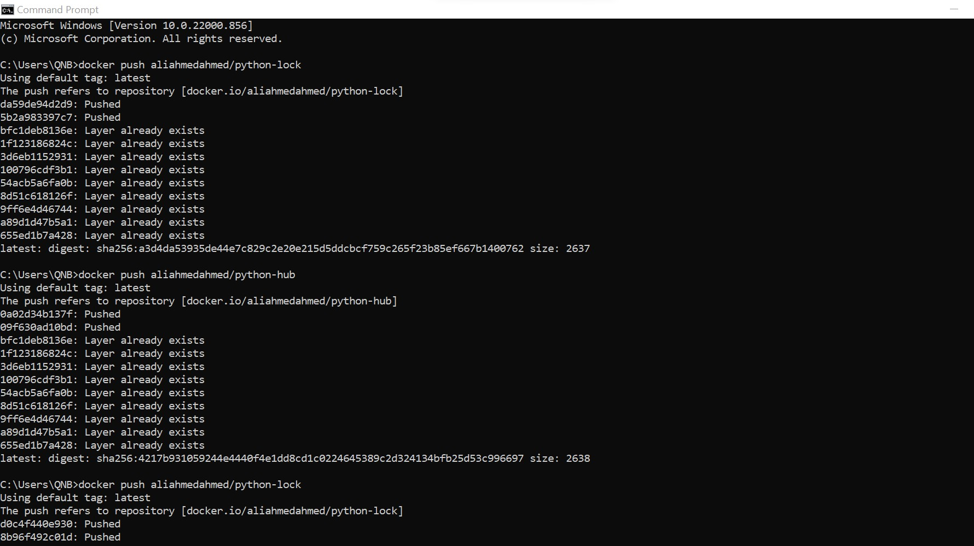

# Docker – Updated Containers / Images

